WEDE2050
2026
Xolani khambule
ST10522662
10/3/2026
Web development
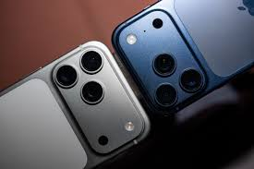

Table of Contents
1. Business overview 3
Name 3
History of the business 3
The business began when the founder bought a new phone while he already had two other phones that were still in good working condition. Instead of letting those phones sit unused, he realised that many people needed mobile phones but could not afford to buy brand-new ones. 3
Mission and vision 3
Mission 3
Our mission is to buy pre-owned phones, repair damaged devices, and sell quality phones while promoting the business through exclusive deals. 3
Vision 3
Target audience 3
The target audience for a pre-owned phone business includes people who want reliable phones at more affordable prices: 3
Students 3
School and college students who need smartphones for studying, communication, and social media but cannot afford expensive new phones. 3
Low to Middle-Income Earners 3
People who want a good working phone at a lower price instead of buying a brand-new device 3
Small Business Owners 3
Business owners who need phones for work purposes and may buy several devices at a lower cost. 3
2. Website goals and objectives 4
Website goal 4
Performance indicators 4
3. Proposed website features and functionality: 5
Website Features 5
Website Functionality 5
4. Design and user experience 6
Colour scheme 6
Typography 6
5. Technical requirements 7
6. Timeline and Milestone 7
7. Budget 7
8. Reference 7

Business overview

Name
Second wave Mobile

History of the business

The business began when the founder bought a new phone while he already had two other phones that were still in good working condition. Instead of letting those phones sit unused, he realised that many people needed mobile phones but could not afford to buy brand-new ones.

He decided to sell his two phones to people who needed them at affordable prices. After seeing how helpful and successful this was, he recognised that there was a strong demand for good-quality pre-owned phones. This experience inspired him to start a business focused on buying and selling reliable pre-owned phones, making technology more accessible to people who may not have the funds to purchase new devices.

Mission and vision

Mission

Our mission is to buy pre-owned phones, repair damaged devices, and sell quality phones while promoting the business through exclusive deals.

Vision
Our vision is to build a successful business with a trusted five-star reputation, gaining popularity and increasing sales through excellent service.

Target audience

The target audience for a pre-owned phone business includes people who want reliable phones at more affordable prices:

Students

School and college students who need smartphones for studying, communication, and social media but cannot afford expensive new phones.

Low to Middle-Income Earners

People who want a good working phone at a lower price instead of buying a brand-new device

Small Business Owners

Business owners who need phones for work purposes and may buy several devices at a lower cost.

Website goals and objectives

Website goal
The website goals and objective is to let people know what the business is about and how it operates. It is to increase the profit of the business and show that it is a professional and a legitimate business and navigate what the consumers want and the price they want it for.

Performance indicators
1. Website Traffic
The number of people who visit the website. High traffic shows that the website is attracting many potential customers.

2. Conversion Rate
The percentage of visitors who buy a phone or contact the business after visiting the website.

3. Sales Generated from the Website
The number of phones sold through the website. This shows whether the website is helping to increase business revenue.

Proposed website features and functionality:

Website Features
Home page
- Displays available pre-owned phones with pictures, prices, and specifications.
Product and services page
- Shows detailed information about each phone, including condition, features, and images.
Special Deals page
- Highlights discounts and exclusive offers on selected phones.
Customer Reviews page
- Allows customers to rate the service and share feedback about their purchases.
About Us Page
- Provides information about the business history, mission, and vision.

Website Functionality
Search and Filter Option
- Allows users to search for phones and filter by brand, price, or condition.
Online Ordering or Booking
- Enables customers to order or reserve phones through the website.
Contact Form
- Allows visitors to send enquiries or messages to the business.
Mobile-Friendly Design
- Ensures the website works properly on smartphones and tablets.
Secure Payment System
- Allows customers to make safe online payments if purchasing through the website.

Design and user experience

Colour scheme
Black
- Show the luxury of the business
Green
- Shows the value of money and sustainability
White
- Shows the cleanliness

Typography
It is going to be simple .I’ll be using aptos font text underline a few word and add bold and italics.
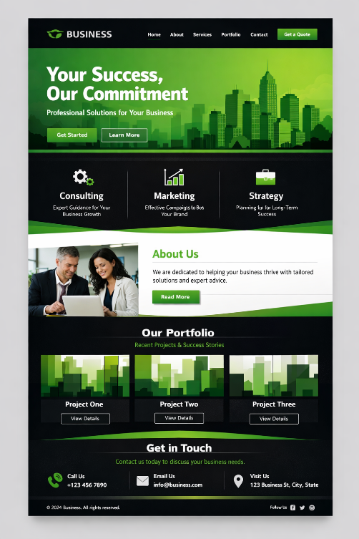

Technical requirements
- HTML
- CSS
- JAVASCRIPT

Timeline and Milestone
Launch website and marketing in Month 1–3. Focus on promotions, social media, and local events to generate leads 4-8 months. Engage customers with testimonials and email campaigns. Review inventory and sales in Month 8. 100 phone need to be sold in 12 months.

Budget
To buys more phones it will require R 50 ,000.To repair damaged phones R10,000.For promotion R5,000 – R 6,000 and the website will cost R25,000.All in all will be R90,000

Reference
Img to Julian Chokkattu (2025) a picture of iphones
https://www.wired.com/review/apple-iphone-17-pro-and-iphone-17-pro-max/
img to chatgpt (2026) a picture of business website layout
https://chatgpt.com/images

